The laboratory work 8
The tic-tac-toe game realization

Looking at a Brief Example
To apply this, let's take an example from near the end of a game, where it is my turn. I am X. My goal here, obviously, is to maximize my end game score.
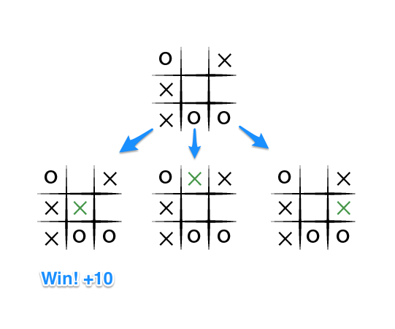
If the top of this image represents the state of the game I see when it is my turn, then I have some choices to make, there are three places I can play, one of which clearly results in me wining and earning the 10 points. If I don't make that move, O could very easily win. And I don't want O to win, so my goal here, as the first player, should be to pick the maximum scoring move.

At the first step we need to create the board and print it
#include "stdafx.h"
#include <iostream>
using namespace std;
void print_board(int board[])
{
int i, j;
for (i = 0; i < 3; i++)
{
cout << " ";
for (j = 0; j < 3; j++)
{
if (board[i * 3 + j] == 1)
cout << " X ";
else if (board[i * 3 + j] == -1)
cout << " O ";
else if (board[i * 3 + j] == 0)
cout << " ";
if (j != 2)
cout << " | ";
}
if (i != 2)
cout << "\n----------------" << endl;
else
cout << " ";
}
cout << "\n" << endl;
}

void print_instructions()
{
cout << "\nThe board is laid out as folows:\n";
cout << " 1 | 2 | 3" << endl;
cout << "-----------------" << endl;
cout << " 4 | 5 | 6" << endl;
cout << "-----------------" << endl;
cout << " 7 | 8 | 9" << endl;
}
int main()
{
int board[9] = { 0,0,0,0,0,0,0,0,0 };
print_instructions();
print_board(board);
return 0;
}

